1. Portal.azure.com

Credits for all images : <https://www.youtube.com/channel/UCNU_lfiiWBdtULKOw6X0Dig>

1. 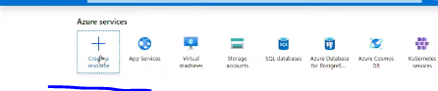

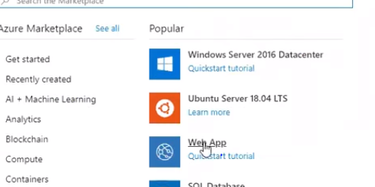

1. 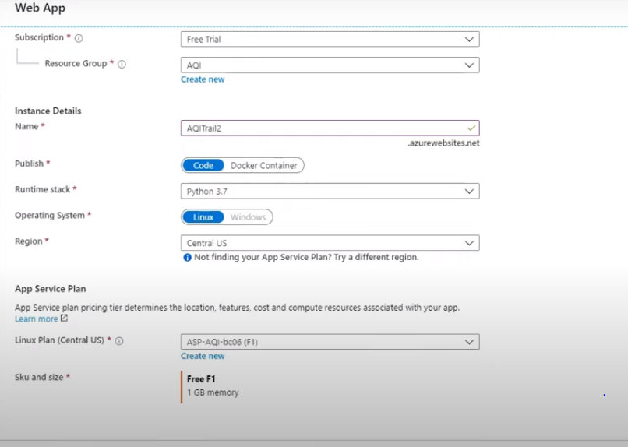

Click on Review and Create

Again click on create

Link code by this app

1. Can connect to github directly

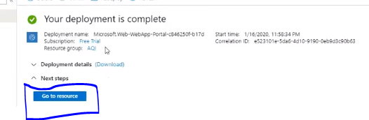

Go TO DEPLOYMENT CENTRE

Go TO GITHUB

Click Continue

Use App Service Build Service

Give your orgname,repo,branch as of github

Click Finish , Your app will start deploying

You can use log to see the deployment

How to get deployed app url

